**EXNO:9 DATE:4/10/2024   
ROLLNO:220701047**

**IMPLEMENTATION OF DECISION TREE CLASSIFICATION TECHNIQUES**

**AIM:** To implement a decision tree classification technique for gender classification using python

.  
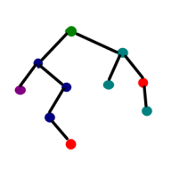

**CODE:**

import pandas as pd

from sklearn.tree import DecisionTreeClassifier

data = {

'Height': [152, 155, 172, 185, 167, 180, 157, 180, 164, 177],

'Weight': [45, 57, 72, 85, 68, 78, 22, 90, 66, 88],

'Gender': ['Female', 'Female', 'Male', 'Male', 'Female', 'Male', 'Female', 'Male', 'Female', 'Male']

}

df = pd.DataFrame(data)

X = df[['Height', 'Weight']]

Y = df['Gender']

classifier = DecisionTreeClassifier()

classifier.fit(X, Y)

height = float(input("Enter height (in cm) for prediction: "))

weight = float(input("Enter weight (in kg) for prediction: "))

random_values = pd.DataFrame([[height, weight]], columns=['Height', 'Weight'])

predicted_gender = classifier.predict(random_values)

print(f"Predicted gender for height {height} cm and weight {weight} kg: {predicted_gender[0]}")

**OUTPUT:**

